A-Z OF FOUNTAIN PEN UNIVERSE

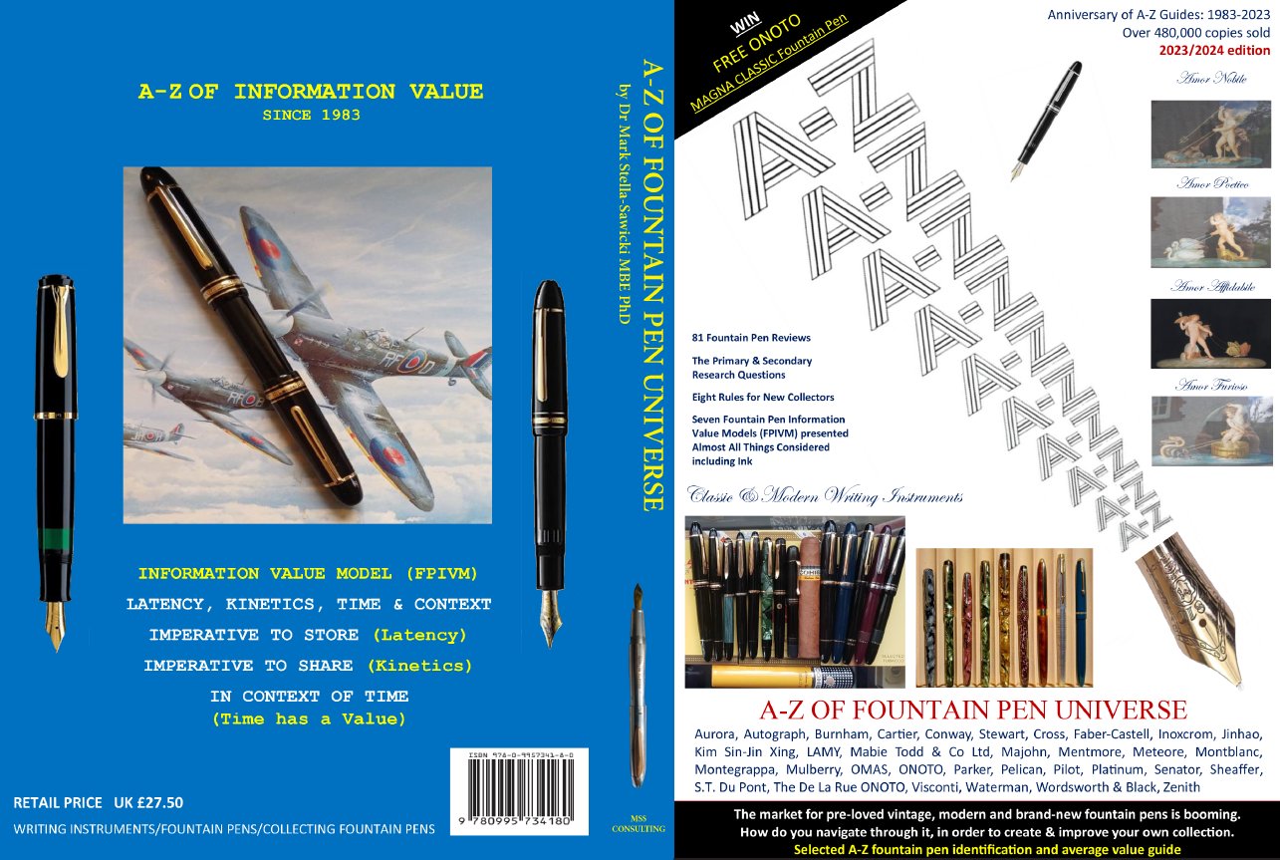

**For overseas orders please email your requests to mssconsulting @hotmail.co.uk**

**A-Z OF FOUNTAIN PEN UNIVERSE**

**at £ 31.30**

**To be mailed to me using 1st Class United Kingdom Postal Service**

